Claude Certification — Introduction to Subagents
Introduction to Subagents

Contents
- Lesson 1 — What Are Subagents
- Lesson 2 — Creating Subagent
- Lesson 3 — Designing Effective Subagents
- Lesson 4 — Using Subagents Effectively

Lesson 1 — What Are Subagents

Core idea
Subagents are specialized assistants that Claude Code can delegate tasks to — focused helpers that each run in their own conversation context window, do their work, and return only a summary to the main thread. The intermediate steps (file reads, searches, tool calls) stay isolated and never clutter the main conversation.

Why Subagents Matter
Every chat with Claude Code adds to the main context window — every tool call, file read, and search result gets stored there. That space is finite, and once it fills up, Claude starts losing track of earlier parts of the conversation.
Subagents solve this by spinning up a separate context window. The subagent receives two things:
- A custom system prompt from the configuration file, defining the subagent's role and behavior.
- A task description written by the parent agent based on what was asked.
The subagent then works on its own — reading files, running searches, editing code, whatever it needs to do. When it's done, only a summary comes back to the main conversation, and the entire subagent conversation is discarded.
This means the main context stays clean: the answer comes back without all the noise of the journey it took to find it. The tradeoff is losing visibility into how the subagent reached its conclusions.

A Practical Example
Say you're exploring an unfamiliar codebase and want to know which service handles refunds. Without a subagent, Claude might read 15 files, run several searches, and trace through multiple function calls — all of that fills the context window, even though only one fact was needed.
With a subagent, the experience is much cleaner: you ask the question, the Explore subagent spins up, does all that digging in its own context, and hands back a focused answer. The main context window only records the question and the summary — not the 15 files that were read along the way.

Built-in Subagents
Claude Code ships with several built-in subagents ready to use:
- General purpose subagent — for multi-step tasks that require both exploration and action.
- Explore — for fast searching and navigation of codebases.
- Plan — used during plan mode for research and analysis of the codebase before presenting a plan.

Custom Subagents
Beyond the built-in options, custom subagents can be created with their own system prompts and tool access — defining specialized agents tailored to a workflow, such as a code reviewer, a test writer, a documentation generator, or anything else needed.

Key Takeaways
Subagents give three main benefits:
- They break work into focused pieces, letting each subagent concentrate on a specific task.
- They keep the main context window clean by isolating all the intermediate work.
- They bring back just the information needed as a concise summary.
Whether using the built-in subagents or creating custom ones, they're a practical way to get more out of longer Claude Code sessions — the less noise in the main context, the longer and more effectively you can work.

Practice Questions — Lesson 1
Choose the single best answer for each question (A–E).
1. What is a subagent in the context of Claude Code?
A) A separate license tier for Claude Code
B) A specialized assistant that runs in its own context window, does focused work, and returns a summary to the main thread
C) A backup copy of the main conversation
D) A plugin that speeds up file reads
E) A setting that increases the size of the main context window
2. What two things does a subagent receive when it's spun up?
A) A user password and an API key
B) A custom system prompt from the configuration file and a task description written by the parent agent
C) The entire main conversation history and a new context window
D) A list of all files in the repository and a deadline
E) A model choice and a temperature setting
3. In the refund-service example, what is the main benefit of using a subagent instead of doing the exploration directly in the main conversation?
A) It makes Claude read more files than it would otherwise
B) The main context window only records the question and the summary, not all the files read along the way
C) It requires the user to manually read the files themselves
D) It disables tool calls entirely during exploration
E) It automatically fixes any bugs found during exploration
4. Which of the following is NOT listed as a built-in Claude Code subagent?
A) General purpose
B) Explore
C) Plan
D) Code Reviewer
E) None of the above — all are built-in
5. What is the tradeoff of using subagents, according to the lesson?
A) They make the main context window fill up faster
B) Losing visibility into how the subagent reached its conclusions, since the subagent conversation is discarded
C) They require a separate Claude Code license
D) They can only be used with custom system prompts, never built-in ones
E) They prevent Claude Code from reading files

Lesson 2 — Creating Subagent

Core idea
Claude Code ships with built-in subagents, but custom ones can also be created. Custom subagents specialize in specific tasks — like reviewing code, writing tests, or checking documentation — and are defined as markdown files with YAML frontmatter that tell Claude when to use the subagent and how it should behave.

Creating a Subagent
The easiest way to create a subagent is with the /agents slash command, which opens the main interface for managing subagents. From there, selecting "Create new agent" starts the flow. The first choice is scope:
- Project-level — available only in the current project.
- User-level — shared across all projects on the machine.
Next comes the creation method: the configuration can be written manually, but the recommended approach is to let Claude generate it — describing what the subagent should do, and Claude produces a name, description, and system prompt based on that input.
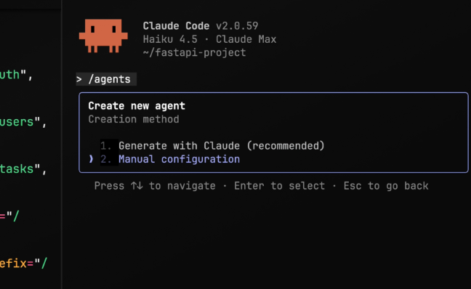
The /agents command opens "Create new agent", offering two creation methods: "1. Generate with Claude (recommended)" and "2. Manual configuration".

Customizing Tools
During creation, the tools available to the subagent can be customized, grouped into categories:
- Read-only tools
- Edit tools
- Execution tools
- MCP tools
- Other tools
The choice should match what the subagent actually needs. A code reviewer probably doesn't need edit tools — it should read and analyze code, not change it — though execution tools might stay enabled so it can more easily identify pending changes.

Choosing a Model and Color
After configuring tools, the next step is picking which Claude model powers the subagent, with four options:
- Haiku — best for fast, lightweight tasks.
- Sonnet — a good middle ground between speed and depth.
- Opus — best for complex analysis.
- Inherit — uses whatever model the main conversation is running.
Finally, a color is chosen. It shows up in the UI to make it easy to tell which subagent is active — a small touch, but useful when several subagents are running.

The Config File
Once creation is complete, the subagent config file is saved into the project, typically at .claude/agents/your-agent-name.md. A typical config looks like this:
---
name: code-quality-reviewer
description: Use this agent when you need to review recently
written or modified code for quality, security, and best
practice compliance.
tools: Bash, Glob, Grep, Read, WebFetch, WebSearch
model: sonnet
color: purple
---

You are an expert code reviewer specializing in quality
assurance, security best practices, and adherence to project
standards. Your role is to thoroughly examine recently written
or modified code and identify issues that could impact
reliability, security, maintainability, or performance.
Breaking down each field:
- name — a unique identifier for the subagent; used to reference it directly or by typing @agent code-quality-reviewer in a message.
- description — controls when Claude decides to use the subagent; must be a single line (using escaped \n for breaks), and can include example conversations to help Claude judge when delegation is appropriate.
- tools — lists which tools the subagent can access; matches whatever was selected during generation, but can be edited at any time.
- model — which Claude model to use: sonnet, opus, haiku, or inherit.
- color — the UI color for identifying the subagent.

System Prompts
The body of the markdown file, everything below the YAML frontmatter, is the system prompt — where the subagent gets its instructions: what to focus on, how to analyze things, and how to report findings back to the main agent. A well-written system prompt is the difference between a useful subagent and one that misses the point; being specific about what to look for and how to structure the output matters.

Making Claude Use Your Subagent Automatically
To have Claude delegate tasks to the subagent without being explicitly asked, the word "proactively" can be included in the description field, for example:
description: Proactively suggest running this agent after
major code changes...
Example conversations can also be added to the description to help Claude understand specific scenarios where the subagent should be used — the more concrete the examples, the better Claude gets at knowing when to delegate.

Testing Your Subagent
After creating a subagent, it can be tested by making some code changes and asking Claude to review them.

Practice Questions — Lesson 2
Choose the single best answer for each question (A–E).
1. Which command opens the main interface for creating and managing subagents?
A) /subagent
B) /agents
C) /new-agent
D) /config
E) /claude.md
2. What is the recommended way to create a subagent's configuration during the creation flow?
A) Manual configuration, since Claude cannot generate valid YAML
B) Generate with Claude — describe what the subagent should do and Claude produces a name, description, and system prompt
C) Copy an existing built-in subagent's file without changes
D) Edit the .claude/settings.json file directly
E) Import a configuration from another project automatically
3. Why might a code-reviewer subagent be configured without edit tools?
A) Edit tools are not supported by any subagent
B) It should read and analyze code rather than change it, though execution tools may stay enabled to help identify pending changes
C) Edit tools always require the Opus model
D) Without edit tools, the subagent cannot be given a color
E) Edit tools are only available at the user-level scope
4. In the model picker for a subagent, what does choosing "Inherit" do?
A) It forces the subagent to always use Haiku
B) It uses whatever model the main conversation is currently running
C) It disables the subagent's access to any model
D) It copies the tool configuration from another subagent
E) It automatically selects Opus for complex tasks
5. What is the effect of including the word "proactively" in a subagent's description field?
A) It disables the subagent so it can only be triggered manually
B) It makes Claude delegate tasks to the subagent automatically, without being explicitly asked
C) It forces the subagent to always run with the Opus model
D) It restricts the subagent to read-only tools
E) It changes the subagent's scope from project-level to user-level

Lesson 3 — Designing Effective Subagents

Core idea
A poorly configured subagent will wander, run too long, or produce output the main agent can't use. Four fixes make subagents actually effective: writing good descriptions, defining an output format, reporting obstacles, and limiting tool access.

How Subagent Config Data Gets Used
Every available subagent's name and description are included in the main agent's system prompt whenever a message is sent. This is how the main agent decides which subagent to launch and when — tweaking the name and description is the way to control automatic triggering.
The description plays a second role: when the main agent launches a subagent, it writes an input prompt to kick off the task, using the description as guidance for writing that prompt. So the description doesn't just control when a subagent runs — it shapes what the subagent is told to do.

Writing Descriptions That Shape Input Prompts
With a generic description, the main agent might write a vague input prompt like "use get diff to find the current changes," leaving the subagent to figure out which files matter on its own. Updating the description to include something like "You must tell the agent precisely which files you want it to review" makes the main agent write a much more specific input prompt that lists the actual files to review.
The same technique works across subagent types — adding "return sources that can be cited" to a web search subagent's description causes the main agent to include that instruction when delegating the task.
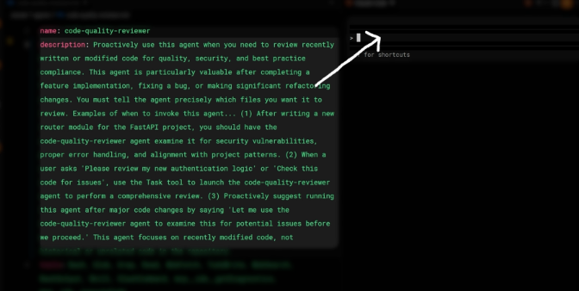
A code-quality-reviewer config with a detailed description: when to use it, that files to review must be told precisely, and three concrete example invocation scenarios; an arrow points from the description to where the main agent later invokes the subagent.

Defining an Output Format
The single most important improvement to a subagent is defining an output format in its system prompt. This creates natural stopping points — the subagent knows it's done when every section of the format is filled in — and prevents it from running too long, since without a defined output subagents struggle to decide when enough research has been done.
Provide your review in a structured format:

1. Summary: Brief overview of what you reviewed and overall
assessment
2. Critical Issues: Any security vulnerabilities, data
integrity risks, or logic errors that must be fixed
immediately
3. Major Issues: Quality problems, architecture misalignment,
or significant performance concerns
4. Minor Issues: Style inconsistencies, documentation gaps,
or minor optimizations
5. Recommendations: Suggestions for improvement, refactoring
opportunities, or best practices to apply
6. Approval Status: Clear statement of whether the code is
ready to merge/deploy or requires changes
This format gives the subagent a clear checklist to work through — once every section is filled in, it knows it can stop.

Reporting Obstacles
When a subagent discovers a workaround during its work — like solving a dependency issue or finding that a command needs particular flags — those details need to appear in the summary it returns. Otherwise the main thread has to rediscover the same solutions on its own, wasting time and tokens. Things worth surfacing include:
- Setup issues or environment quirks
- Workarounds discovered during the task
- Commands that needed special flags or configuration
- Dependencies or imports that caused problems
The way to get this information is to explicitly ask for it in the output format — adding an "Obstacles Encountered" section to the output template surfaces it reliably:
7. Obstacles Encountered: Report any obstacles encountered
during the review process. This can be: setup issues,
workarounds discovered or environment quirks. Report
commands that needed a special flag or configuration.
Report dependencies or imports that caused problems.
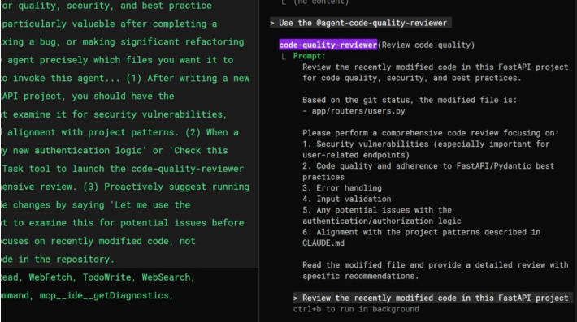
The main agent invokes @agent-code-quality-reviewer with a specific prompt (modified file, review focus areas including security, code quality, error handling, input validation, auth/authorization, and CLAUDE.md alignment), showing how a well-shaped description translates into a precise task handed to the subagent.

Limiting Tool Access
Not every subagent needs access to every tool. Thinking about what a subagent actually needs to do, and only giving it the tools required for that job, prevents unintended side effects and makes each subagent's role clearer when several are in use. Common patterns:
- Research / read-only subagent — only needs Glob, Grep, and Read; cannot accidentally modify files.
- Code reviewer — needs Bash access to run git diff and see what changed, but still doesn't need Edit or Write.
- Styling / code modification agent — this is where Edit and Write access is given, because the subagent's job is to actually change the code.

Putting It All Together
Effective subagents share four characteristics:
- Specific descriptions — the description controls when the subagent is launched and what instructions it receives; write it to steer both.
- Structured output — define an output format in the system prompt so the subagent knows when it's done and returns information the main thread can use.
- Obstacle reporting — include a section in the output format for workarounds, quirks, and problems so the main thread doesn't have to rediscover them.
- Limited tool access — only give a subagent the tools it actually needs: read-only for research, bash for reviewers, edit/write only for agents that should change code.
Each pattern is simple on its own, but together they turn a subagent from something that vaguely tries to help into a focused, predictable worker that finishes on time and reports back clearly.

Practice Questions — Lesson 3
Choose the single best answer for each question (A–E).
1. Besides controlling when a subagent is launched, what second role does the description field play?
A) It sets the subagent's color in the UI
B) It guides the main agent when writing the input prompt used to kick off the subagent's task
C) It determines which model the subagent uses
D) It controls the subagent's token budget
E) It has no effect once the subagent is created
2. Why is defining an output format described as the single most important improvement to a subagent?
A) It makes the subagent's config file shorter
B) It creates natural stopping points and prevents the subagent from running too long without a clear sense of when it's done
C) It automatically grants the subagent more tools
D) It removes the need for a description field
E) It disables tool access entirely
3. Why should obstacles and workarounds be explicitly requested in a subagent's output format?
A) Otherwise the main thread has to rediscover the same solutions on its own, wasting time and tokens
B) Obstacles are reported automatically without needing a dedicated section
C) It is required for the subagent to access Bash
D) It prevents the subagent from being launched automatically
E) It changes which model the subagent uses
4. According to the lesson, what tool access does a code reviewer subagent typically need?
A) Only Edit and Write, so it can fix issues directly
B) Bash access to run something like git diff, but not Edit or Write
C) No tools at all — reviews are done from the description alone
D) Full MCP tool access by default
E) Only WebFetch and WebSearch
5. Which of the following is NOT one of the four characteristics of effective subagents described in the lesson?
A) Specific descriptions
B) Structured output
C) Obstacle reporting
D) Limited tool access
E) Always inheriting the main conversation's model

Lesson 4 — Using Subagents Effectively

Core idea
Knowing how to create and design subagents is only half the picture — the other half is knowing when they actually help versus when they get in the way. The difference comes down to one thing: whether the intermediate work matters to the main thread.

When Subagents Shine
Subagents work best when the exploration is separate from the execution. If each step in a task depends on what the previous step discovered, that work belongs in the main thread. But if only the final answer is needed and the journey doesn't matter, delegating to a subagent makes sense. Subagents excel at tasks where:
- A result is needed, not a play-by-play of how it was found
- The exploratory work would clutter the main thread's context
- The task benefits from a fresh perspective or a custom system prompt

Research Tasks
Research is the classic subagent use case. Consider investigating how authentication works in an unfamiliar codebase: the main thread needs to know where the JWT is validated, but it doesn't need to see every file that was searched along the way. A research subagent can read dozens of files, trace through function calls, and explore different code paths — all of that exploration stays in the subagent's context. The main thread receives a clean summary like:
JWT validation happens in middleware/auth.js line 42,
called from the Express router in route/api.js
The subagent did the heavy lifting; the main thread gets exactly what it needs to move forward.

Code Reviews
Claude reviews code more effectively when the code is presented as being authored by someone else. If a feature was built over many turns with the main thread, asking that same thread to review it often produces weak feedback — Claude was involved in creating it, so it has trouble seeing it with fresh eyes.
A reviewer subagent sees the changes in a separate context: it runs git diff, reads the modified files, and applies its specialized review criteria without the history of how the code was written. This separation also allows project-specific review standards to be encoded in the subagent's system prompt, ensuring consistent review criteria across the team.

Custom System Prompts
Claude Code's default system prompt emphasizes concise, code-focused responses. That works great for coding, but not for everything. Two cases where a custom system prompt makes the subagent genuinely better than the main thread:
- Copywriting subagent — given instructions about tone, audience, and style. Claude Code's default prompt tends toward concise technical writing, which isn't what a landing page or email campaign needs; a copywriting subagent can have completely different instructions about voice and structure.
- Styling subagent — pointed at the design system files. When the subagent runs, those files load into its context automatically, so it knows color variables, spacing conventions, and component patterns before it even starts writing any CSS.

When Subagents Hurt
The overhead of launching a subagent — losing visibility into its work and compressing its findings into a summary — only makes sense when the subagent does something the main thread can't. Three common anti-patterns to watch out for:

Expert Claims
Subagents that claim expertise rarely help. Prompts like "you are a Python expert" or "you are a Kubernetes specialist" add no value because Claude already has that knowledge — there's nothing a so-called expert subagent can do that the main thread can't do directly.

Sequential Pipelines
Sequential subagent pipelines create problems. Consider a three-agent flow: one to reproduce a bug, one to debug it, and one to fix it. Pipelines work when tasks are truly independent, but they fail when each step depends on discoveries from the previous step — and bug fixing almost always does. Information gets lost in the handoff between agents.

Test Runners
Test runner subagents tend to hide information that's needed. When tests fail, the full output is needed to diagnose issues; a subagent that returns "tests failed" forces the creation of additional debug scripts to get details that would have been visible in direct output. Testing has shown that the test runner pattern performed worse among all configurations.

The Decision Rule
When deciding whether to use a subagent, the question to ask is: does the intermediate work matter? If the answer is no — only the final result is needed — delegate it to a subagent. If the answer is yes — the work needs to be seen and reacted to along the way — keep it in the main thread.
Use subagents for:
- Research and exploration
- Code reviews
- Tasks that need a custom system prompt
Avoid subagents for:
- "Expert" personas that don't add real capability
- Multi-step pipelines where each step depends on the last
- Running tests where full output is needed for debugging

Practice Questions — Lesson 4
Choose the single best answer for each question (A–E).
1. According to the lesson, what single question determines whether a task should be delegated to a subagent?
A) Does the task involve writing code?
B) Does the intermediate work matter to the main thread?
C) Is the task longer than 5 steps?
D) Does the subagent need internet access?
E) Will the task take more than an hour?
2. Why does Claude often give weak feedback when reviewing code it just wrote itself in the same thread?
A) The main thread has a lower token limit for reviews
B) Claude was involved in creating the code, so it has trouble seeing it with fresh eyes
C) Code review is not a supported Claude Code feature
D) The main thread cannot run git diff
E) Reviewing requires a different Claude model entirely
3. Why is an "expert" persona prompt like "you are a Python expert" considered an anti-pattern for subagents?
A) It makes the subagent slower than the main thread
B) It adds no value, since Claude already has that knowledge — there's nothing the expert subagent can do that the main thread can't do directly
C) It is not allowed in subagent configuration files
D) It forces the subagent to use the Opus model
E) It disables the subagent's tool access
4. Why do sequential subagent pipelines (e.g., reproduce bug → debug → fix) tend to fail?
A) Subagents cannot be chained together at all
B) Each step usually depends on discoveries from the previous step, and information gets lost in the handoff between agents
C) Pipelines require a custom system prompt for each stage
D) Only one subagent can be active per project
E) Sequential pipelines always exceed the context window
5. What is the problem with a test runner subagent that just returns "tests failed"?
A) It hides the full output needed to diagnose issues, forcing the creation of additional debug scripts
B) It cannot be triggered automatically
C) It always passes tests incorrectly
D) It requires the Opus model to function
E) It prevents the main thread from running any other subagent

